# **Download & Install Tools**

**Download & Install Tools** **1**

**Download & Install Java JDK 8 in Windows** **2**

How to set Environment Variables in Java: Path and Classpath 5

**Download and install IntelliJ IDEA** **10**

**Download and Install Apache Maven** **11**

Add MAVEN_HOME system variable 11

Add %MAVEN_HOME%\bin To PATH 12

**Install H2 Database** **14**

# 

# **Download & Install Java JDK 8 in Windows**

This Java Development Kit(JDK) allows you to code and run Java programs. It's possible that you install multiple JDK versions on the same PC. But Its recommended that you install only latest version.

**How to install Java for Windows**

Following are the steps for JDK 8 free download for 32 bit or JDK 8 download 64 bit and installation

**Step 1)** Go to the [link](https://www.oracle.com/java/technologies/javase-downloads.html). Click on JDK Download for Java JDK 8 download.

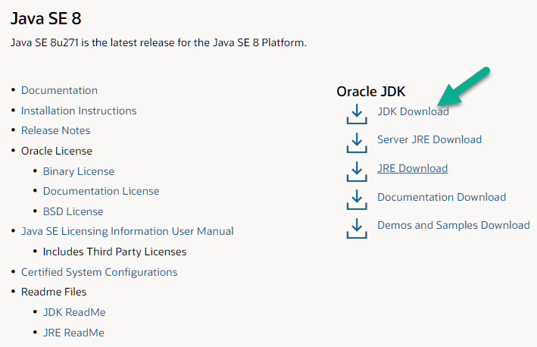

**Step 2)** Next,

1. Accept License Agreement
2. Download Java 8 JDK for your version 32 bit or JDK 8 download for windows 10 64 bit.

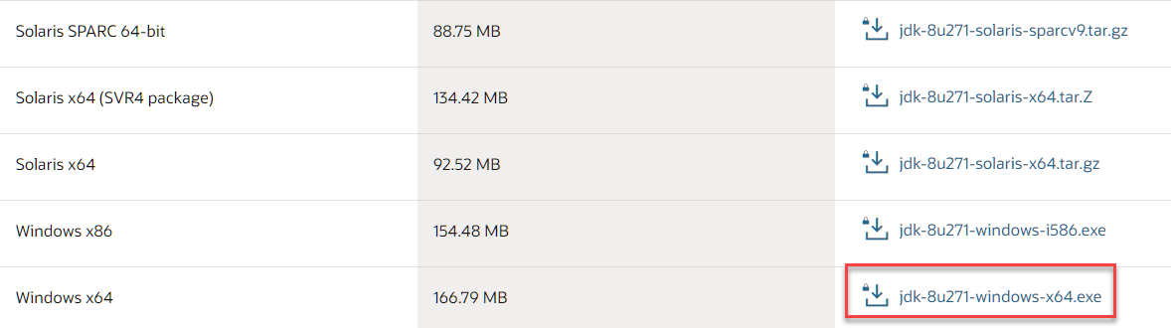

**Step 3)** When you click on the Installation link the popup will be open. Click on I reviewed and accepted the Oracle Technology Network License Agreement for Oracle Java SE and you will be redirected to the login page. If you don't have an oracle account you can easily sign up by adding the basic details of yours.

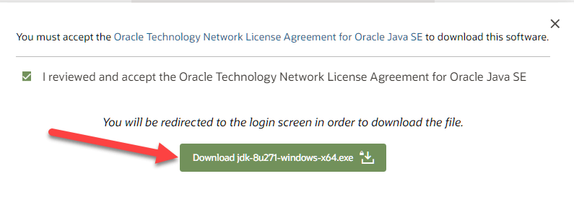

**NOTE:** You will be required to create an Oracle Account to start download of the file.

**Step 4)** Once the Java JDK 8 download is complete, run the exe to install JDK. Click Next

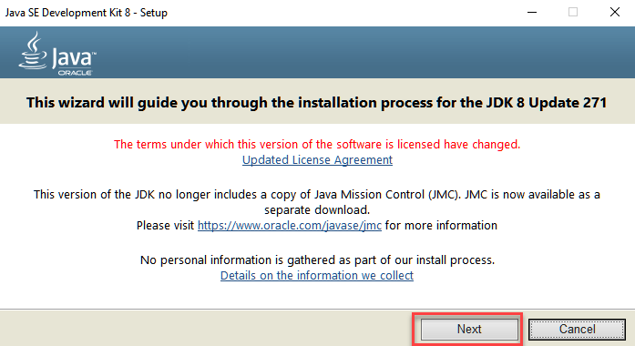

**Step 5)** Select the PATH to install Java in Windows… You can leave it Default. Click next.

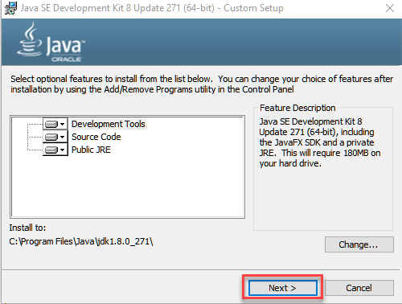

**NOTE:** Follow the onscreen instructions in succeeding installation steps.

**Step 6)** Once you install Java in windows, click Close

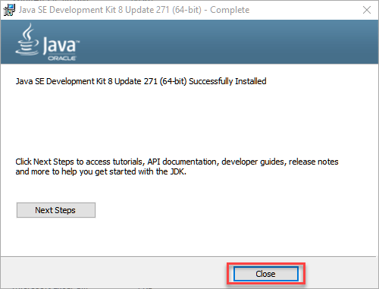

## **How to set Environment Variables in Java: Path and Classpath**

The PATH variable gives the location of executables like javac, java etc. It is possible to run a program without specifying the PATH but you will need to give full path of executable like **C:\Program Files\Java\jdk1.8.0_271\bin\javac A.java** instead of simple **javac A.java**

The CLASSPATH variable gives location of the Library Files.

Let's look into the steps to set the PATH and CLASSPATH

**Step 1)** Right Click on the My Computer and Select the properties

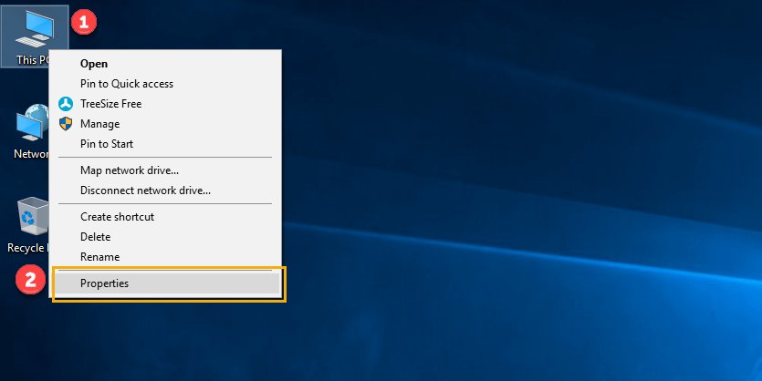

**Step 2)** Click on advanced system settings

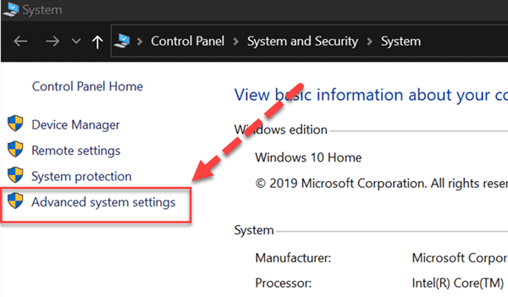

**Step 3)** Click on Environment Variables

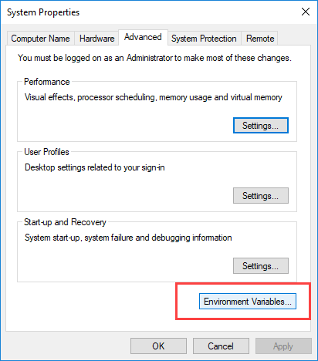

**Step 4)** Click on new Button of User variables



**Step 5)** Type PATH in the Variable name.

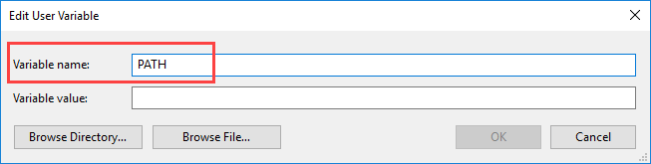

**Step 6)** Copy the path of the bin folder which is installed in JDK folder.

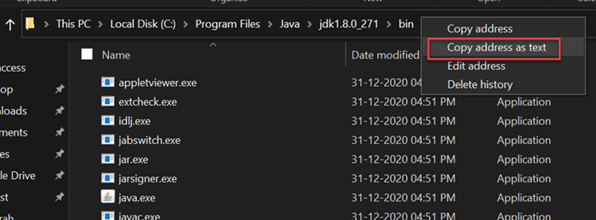

**Step 7)** Paste Path of bin folder in Variable value. Click on OK Button.

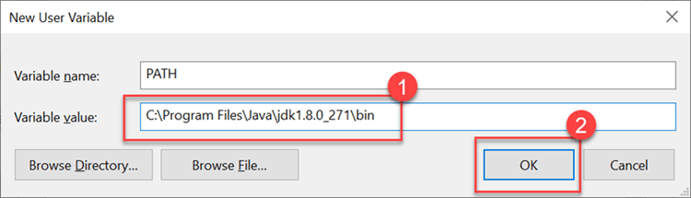

**Note:** In case you already have a PATH variable created in your PC, edit the PATH variable to

PATH = <JDK installation directory>\bin;%PATH%;

Here, %PATH% appends the existing path variable to our new value

**Step 8)** You can follow a similar process to set CLASSPATH.

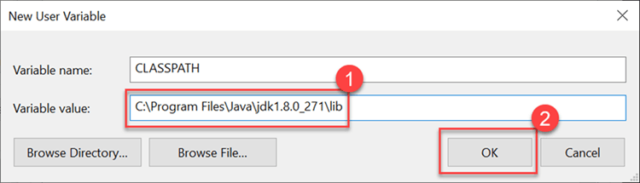

**Note:** In case you java installation does not work after installation, change classpath to

CLASSPATH = <JDK installation directory>\lib\tools.jar;

**Step 9)** Click on OK button



**Step 10)** Go to command prompt and type javac commands.

If you see a screen like below, Java is installed.

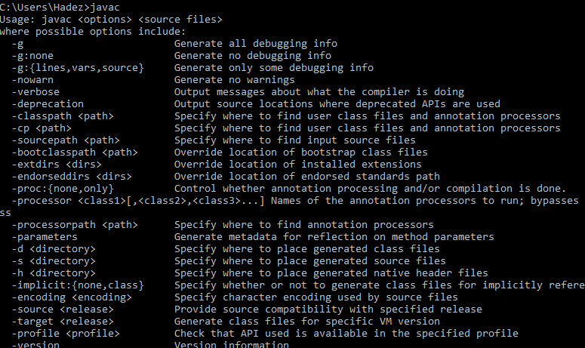

# **Download and install IntelliJ IDEA**

Like Eclipse and NetBeans, it’s pretty easy to download, install, and get IntelliJ IDEA up and running to start coding. Note that your computer should have at least 4GB of RAM to run the IDE smoothly.

Although IntelliJ IDEA is bundled with JRE 8, you still need to have JDK 8 or higher installed on your computer first. That means the IDE is running on its own JRE and requires a separate JDK for Java development.

Click this URL to open the download page:

<https://www.jetbrains.com/idea/download/>

You will see the following screen:

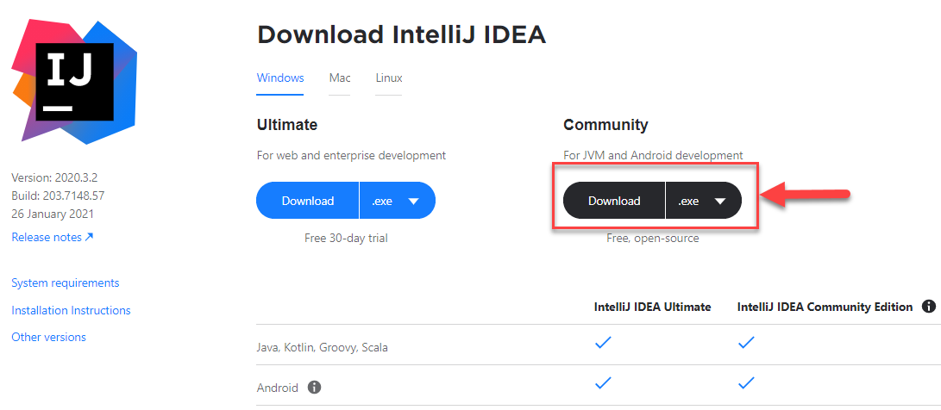

Here, you can download the Community edition for Windows, Mac or Linux. On Windows, you can download either an installer (EXE) or a Zip package.

**Install IntelliJ IDEA using Installer**

Click Download .EXE to start downloading the installer program. Once download is completed, run the installer program.

# **Download and Install Apache Maven**

Visit [*Maven official website*](https://maven.apache.org/download.cgi), download the Maven zip file.

Unzip it to a folder.

## **Add MAVEN_HOME system variable**

Add a MAVEN_HOME system variable, and point it to the Maven folder.

Press Windows key, type adva and clicks on the View advanced system settings

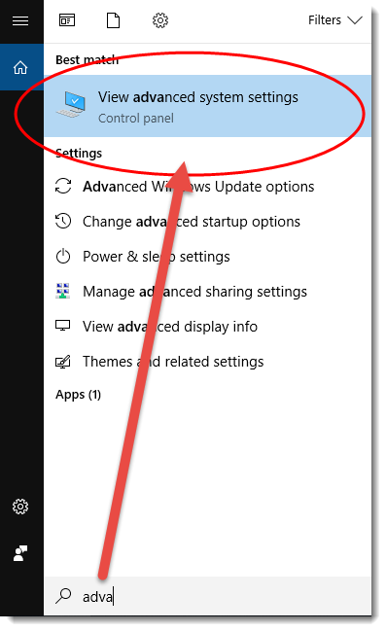

In the System Properties dialog, select Advanced tab and click on the Environment Variables... button.

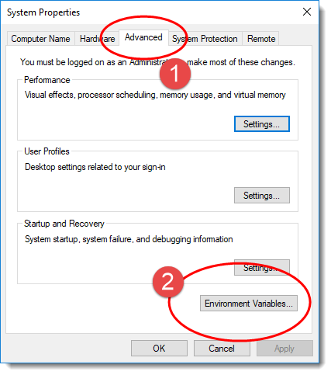

In “Environment variables” dialog, System variables, Clicks on the New... button and add a MAVEN_HOME variable and point it to c:\opt\apache-maven-3.6.0

## **Add %MAVEN_HOME%\bin To PATH**

In User variables, find PATH, click on the Edit... button. In “Edit environment variable” dialog, clicks on the New button and add this %MAVEN_HOME%\bin

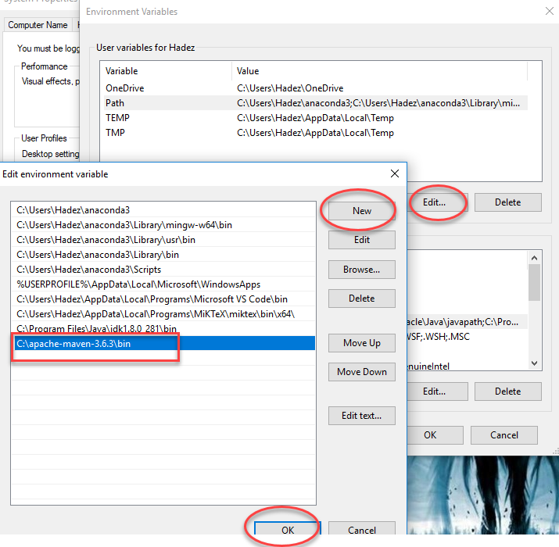

**Verification**

Done, start a new command prompt, type mvn -version :

|  |
| --- |
| mvn -version |

The Apache Maven is installed successfully on Windows.

# **Install H2 Database**

Following are the steps to install H2 Database on Windows operating systems.

**Step 1: Download H2 Setup File**

Download the latest version of [H2 Database](https://www.h2database.com/html/download.html) from the given link. In this link, you will get the latest version of H2 database in two types. One is Windows Installer type (that is .exe file) and second is Platform-Independent zip file for other operating systems.

Click the Windows installer for downloading the Windows supportable H2 database after downloading the .exe file.

**Step 2: Install H2 Database**

After downloading we get the H2 Windows installer file in the Downloads directory. To start the installation process of H2 Database, double click on the installer file.

The following screen is the first step in the installation process. Provide a path where we want to install the H2 database server as shown in the following screenshot.

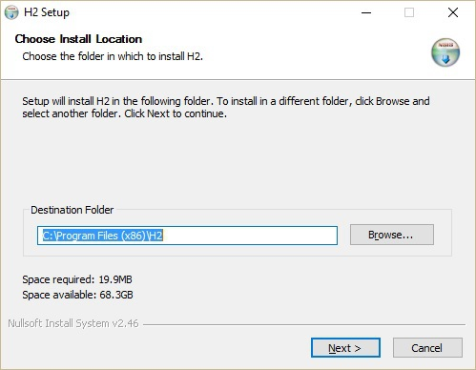

As seen in the above screenshot, by default it will take C:\ProgramFiles (x86)\H2 as the destination folder. Click next to proceed to the next step. The following screen pops up.

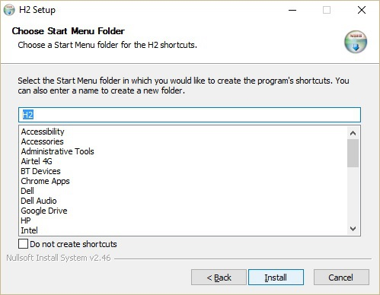

In the above screenshot, click the Install button to start the installation process. After installation, we get the following screenshot.

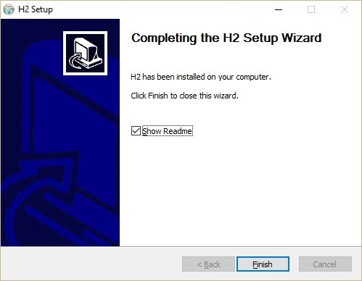

Click Finish to complete the installation process.

**Step 3: Verify H2 Database Installation**

After installation, let us verify the database installation in the system. Click Windows → type H2 Console → Click H2 console icon. Connect to the URL http://localhost:8082. At the time of connecting, the H2 database will ask for database registration as shown in the following screenshot.

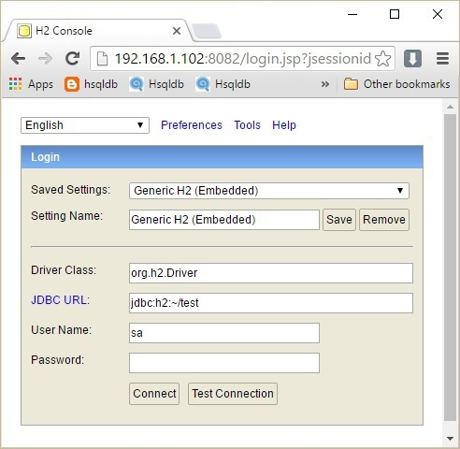

Fill all the details in the above dialog box such as Saved Settings, Settings Name, Driver Class, JDBC URL, User Name, and Password. In the JDBC URL, specify the database is located and the database name. Username and Password are the fields for username and password of the database. Click Connect.

The Database welcome page pops up as shown in the following screenshot.

